The goal of this module is to familiarize you with the basics of networking in the Microsoft Windows operating system. These commands are very useful to understanding the topology of the network you are working on, either here or in the field.

Assignment Due Date: Sunday, 02/08/09 by 11:59 PM
Total Points: 20
Submission Requirements: paste your answers in the body of a WebCT/Bb mail message (addressed to the instructor only)

Open a command prompt by clicking:  Start -> Run  typing:  cmd  and clicking Ok. | 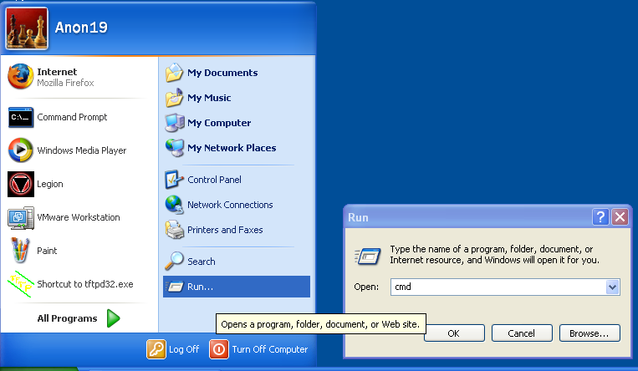
Run the command:  dir /?  to list all the options for the dir command. | 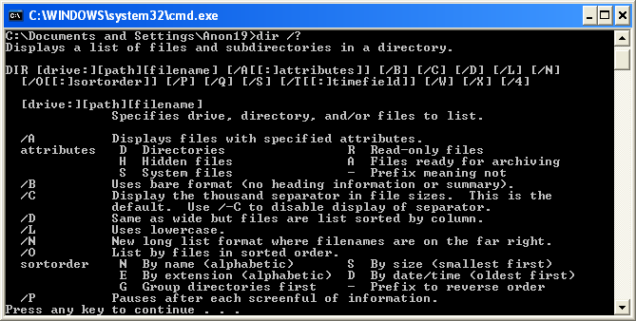
Now, pipe the output from dir to more by typing:  dir | more | 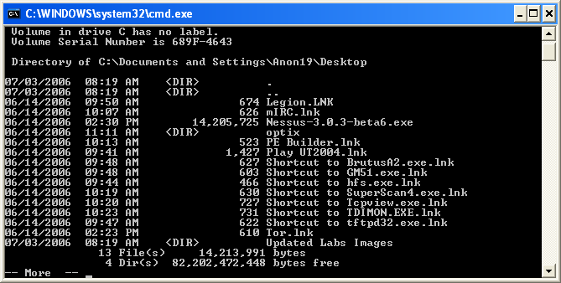
Now, redirect the output from the dir command to a file by typing:  dir >> listing.txt  Open the listing.txt file in Notepad and view the contents. | 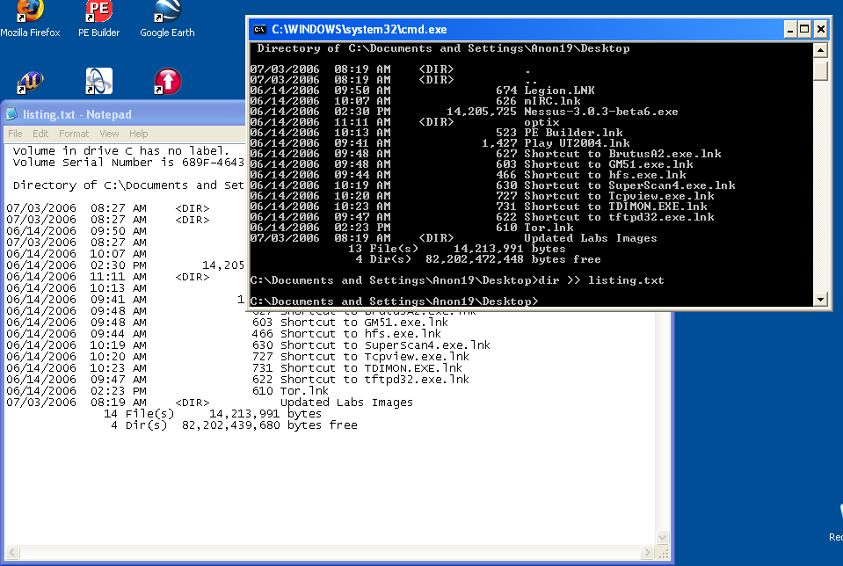
Next, you will determine where you are on the network. At the command prompt type:  ipconfig  - IP address: _________________________  - Default gateway: ____________________ | 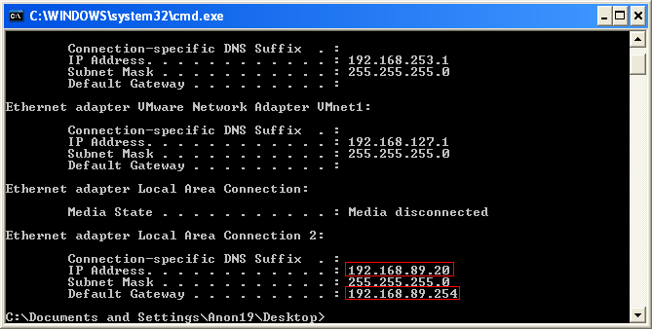
The ping command requires an IP address or a fully qualified domain name (FQDN). To ping the IP address 192.168.89.5 you would type:  ping 192.168.89.5  Ping your default gateway (the IP address from the previous step)  - Is your gateway alive? ________________ | 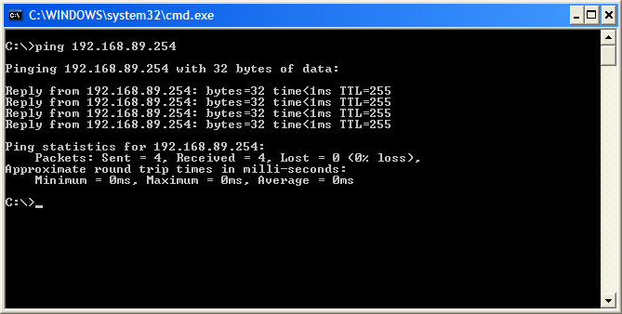
To request a new IP address from a DHCP server (assuming one is running in your network environment) type the following commands at the command prompt:  ipconfig /release  ipconfig /renew | 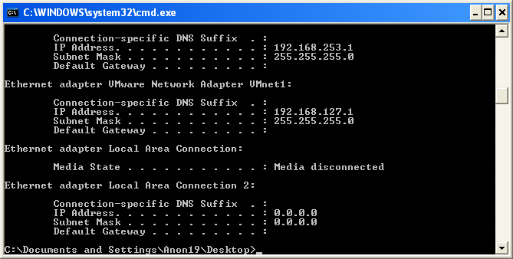
Your ARP table maintains a cache of MAC-to-IP address pairings. To view your ARP cache type:  arp -a  - What is the MAC address of your default gateway?  __________________________________  - How many interfaces are listed?  _____________  - How many entries are there for each?  _____________  - What piece of hardware does the physical (MAC) address refer to in each entry?  ________________________________ | 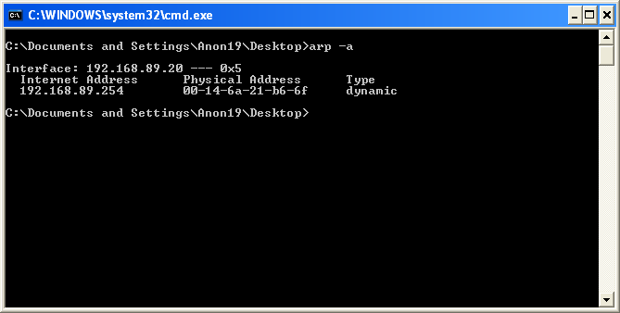
Domain names are mappings between fully qualified domain names (FQDNs) and IP addresses. At the command prompt type:  nslookup  When the prompt appears type the name of your favorite news website (e.g. www.cnn.com, www.fark.com, etc.)  - What is the IP address of the site (there may be more than one)?  _________________________________  - Choose one of the IP addresses from above and type it into nslookup. What is the FQDN of your chosen IP address?  _________________________________  Type exit to leave the nslookup program. | 