The goal of this assignment is to familiarize you with basic networking concepts.

Assignment Due Date: Sunday, 02/08/09 by 11:59 PM
Total Points: 20
Submission Requirements: paste your answers in the body of a WebCT/Bb mail message (addressed to the instructor only)

Open a command prompt by clicking:  Start -> Run  then typing:  cmd  in the box that appears. | 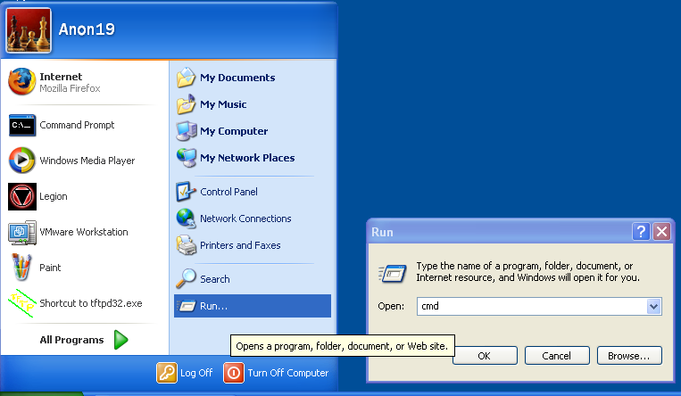
At the command prompt type the command:  ipconfig /all | 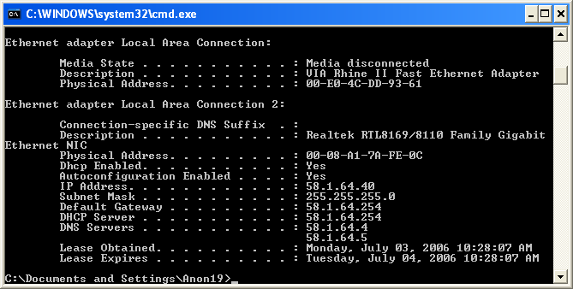
Exercise Questions:

- How many devices are listed?

- What is the MAC address (Physical Address) of each?

- What is the IP address of each?

- For each IP, is it a static or dynamic address? How can you tell?

- What is the default gateway of the system?

- What is the subnet mask?

- Is this a class A, B, or C network?

Review: Things you need to get onto a network

IP Address: Unique identifier for each machine on the network.  Subnet mask: Defines which part of your IP is the host ID and which is the network ID. All hosts on a TCP/IP network must share the same network ID and subnet mask.  Default gateway: The first “hop” before getting out of your network. This is typically a router or firewall.  DNS Server: IP address of the Domain Name Server machine. Used to resolve names (www.ccbcmd.edu) into IP addresses.  Static IP Addresses are assigned by the user at the terminal and remain the same until they are manually changed.  Dynamic IP addresses are assigned over the network by a Dynamic Host Configuration Protocol (DHCP) server machine and may change when their lease expires.  (see bottom-right) | 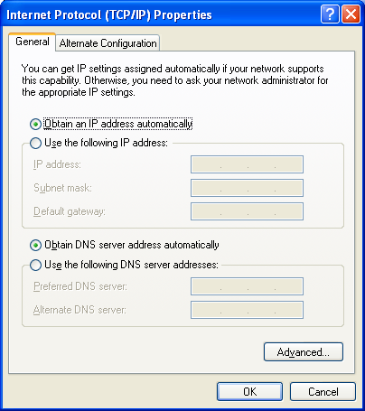  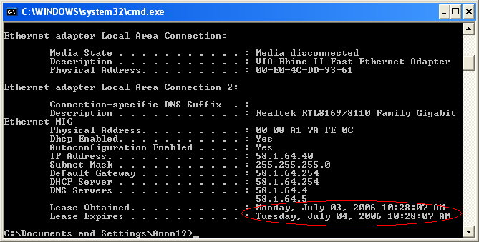
Exercise: Change your computer’s IP settings

Objective: Locate and change the IP configuration of a computer.

Open the network connections page, this is found under the Control Panel. To open the Control Panel click:  Start -> Control Panel | 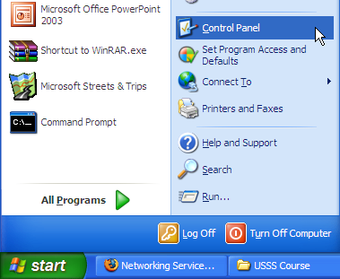
Double-click on the Network Connections icon. | 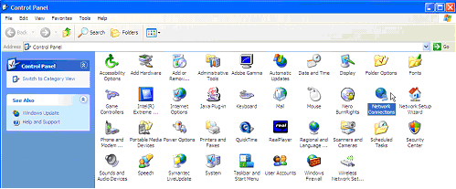
There may be several adapters listed on this page. These will be similar to what you observed with the ipconfig command.  Some of the connections you might see are:  Local Area Connection -> wired LAN Port  1394 Connection -> Firewire port  VMWare Network Adapters -> Software adapter connections installed by VMWare  Other adapters may be present depending on the system configuration. | 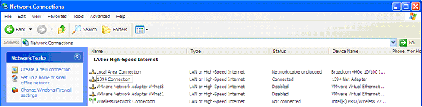
Double-click the network adapter you wish to modify, this will be the adapter labeled Connected under Status.  Note: For this lab you will be using Local Area Connection.  Scroll down to the bottom of the list until you see the Internet Protocol (TCP/IP) icon.  Left-click once to select it then click the Properties button to bring up the window pictured below.  If there are IP addresses, subnet masks, default gateway and DNS settings present – write them down before you do anything else! | 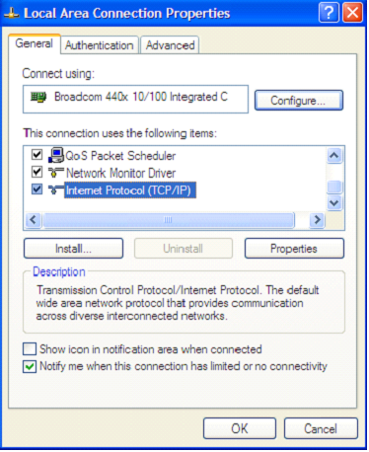  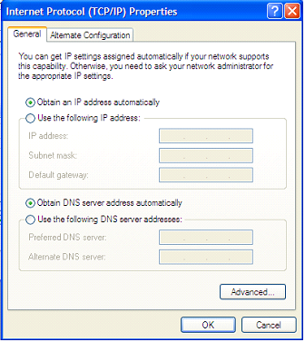
Change the entry in the IP address box to: 123.45.67.89 or 56.88.34.5  Click OK  Try to access the network or surf the Internet.  Are you still connected? ____________________  Why? ___________________________________ | 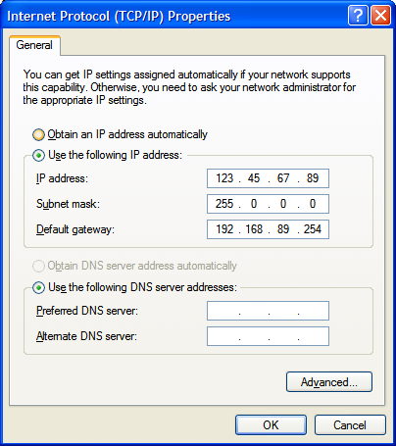
Change the Subnet Mask and Default Gateway boxes to either of the numbers above.  Which one of these three, if changed, will still allow you to access the local network but not the Internet?  _______________________________________  Why? __________________________________  _______________________________________ | 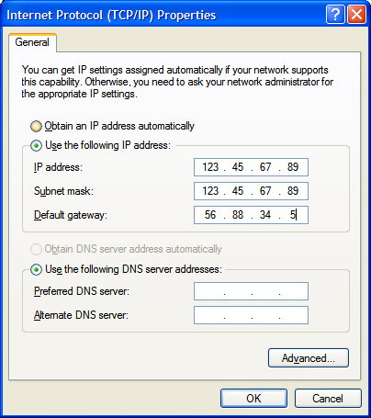
Change the IP address, subnet mask and default gateway back to their original settings.

